Peace School, London (2020)

Art poster and poem by PS Student (Age 15)
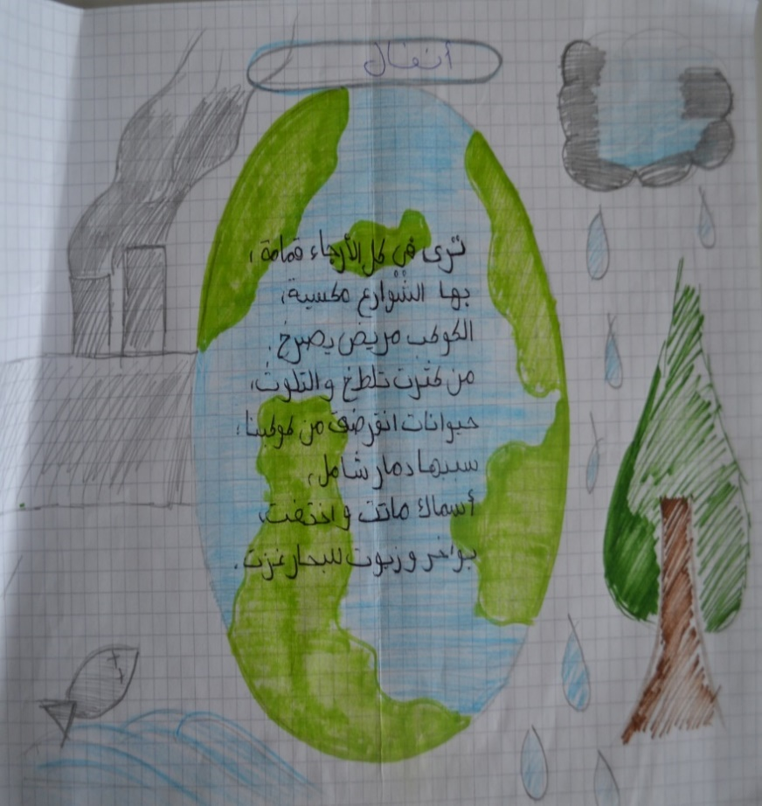

I see rubbish in every corner
With it the streets are covered
Our planet is ill, screaming
Full of pollution
Animals are becoming extinct
It is caused by mass destruction
Fishes died and disappeared
Ships and oils of the sea invaded
By PS Student

Commentary
Pollution has been the cause for many problems in our lives and this is why I wrote this poem for the world to know that our planet is suffering. I drew factories and smoke around the planet to represent that smoke from the factories and other vehicles are the major cause of pollution. At the bottom there is a fish screaming and shouting for help, asking the boats to stop poisoning them with the oil that destroyed the sea. Through this poster, I want to inform everyone that pollution is not good for humans and animals. This planet is our home and we need to take care of it and try to make it a better place.
By PS Student

Art poster and poem by PS Student (Age 13)

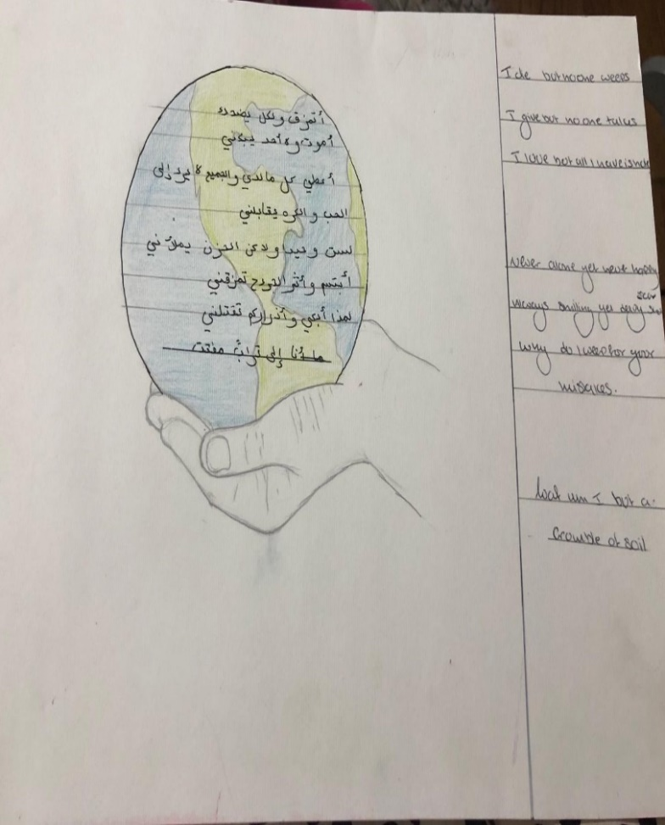
I die but no one weeps
I give but no one takes
I love but all I have is hate
Never alone but never happy
Always smiling yet deeply scaring
Why do I weep for your mistakes
What am I but a crumble of soil

By PS Student
Commentary:
I drew the hand to signify that the earth is in our hands and that it is a (unified act) whether we decide to destroy it or take care of it is our choice. In the poem I decided to personify the earth to convey its feelings and hardships.
By PS Student

Art poster and poem by PS Student (Age 15)

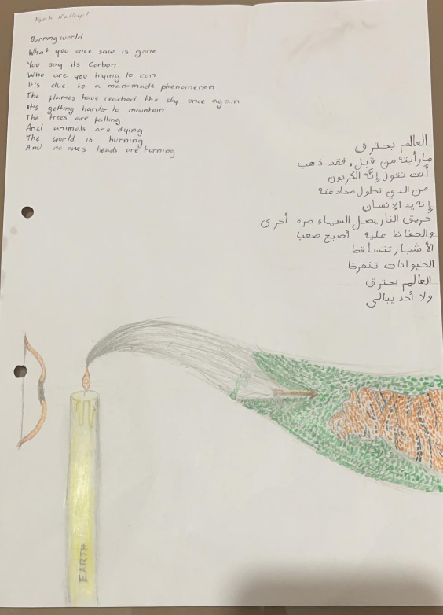
Burning world

What you once saw is gone
You say it’s carbon
Who are you trying to con
It’s due to a man-made phenomenon
The flames have reached the sky once again
It’s getting harder to maintain
The trees are falling
And animals are dying
The world is burning
And no one’s heads are turning

By PS Student
Commentary
What the picture is meant to represent is … the candle is a kind of stick and is meant to represent the earth, whilst the flame represents us. … It’s the earth that’s sacrificing itself, the planet that’s sacrificing itself for our needs in order to give us life. … The bow and arrow … the bow is the problems that we have and the arrow is the problems that are shooting out towards the world. And if can you look closely at the picture with the tiger and the leaves, it’s like the arrow is penetrating the world so you can see that the world is kind of fighting back but it’s like not really fighting back and I also chose the tiger because the tiger is almost extinct. So it’s almost as if, if that penetrated that wall, then the tigers would be extinct like loads of animals.
By PS Student

